Part Number: PT942-47160

Kit Contents
Item # | Quantity Reqd. | Description
1 | 1 | Illuminated Scuff Plate, Front Right Hand
2 | 1 | Illuminated Scuff Plate, Front Left Hand
3 | 1 | Illuminated Scuff Plate, Rear Right Hand
4 | 1 | Illuminated Scuff Plate, Rear Left Hand
5 | 1 | Hardware Kit
Hardware Bag Contents
Item # | Quantity Reqd. | Description
1 | 4 | T-Tap Connector
2 | 23 | 10” Wire Tie
3 | 4 | Tape, Foam 25 x 50 mm
4 | 2 | Pinch Weld Bridge
Additional Items Required For Installation
Item # | Quantity Reqd. | Description
1
2
3
4
Conflicts
Models without foot lights
General Applicability
Prius models with foot lights only
Recommended Sequence of Application
Item # | Accessory
1
2
3
*Mandatory
NOTE
For left-hand drive vehicles:
Left side = Driver side
Right side = Passenger side
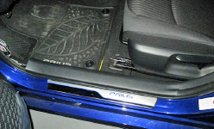
Recommended Tools
Personal & Vehicle Protection | Notes
Safety Glasses
Safety Gloves | Optional
Blankets
Part Boxes
Special Tools | Notes
Panel Removal Tool | e.g. Toyota SST P/N:  00002-06001-01
Non-intrusive Infrared Temp
Probe/Gun
Installation Tools | Notes
Wrench | 10mm
Socket | 10mm
Pliers | For T-Taps
Side Cutters | For Wire Ties
Torque Wrench | 5.4 N-m (48 lbf-in)
Wiping Cloth | For cleaning pinch weld
#2 Phillips Head Screwdriver
Hard Rubber Hand Roller | 1” to 3” wide  i.e. Marshalltown E54D or  Dynamat 10007
Special Chemicals | Notes
VDC Approved Cleaner
Vehicle Service Parts (may be required for reassembly)
Item # | Quantity Reqd. | Description
1
2
3
Legend
STOP: Damage to the vehicle may occur. Do not proceed until process has been complied with.
OPERATOR SAFETY: Use caution to avoid risk of injury.
CAUTION: A process that must be carefully observed in order to reduce the risk of damage to the accessory/vehicle and to ensure a quality installation.
TOOLS & EQUIPMENT: Used in Figures calls out the specific tools and equipment recommended for this process.
REVISION MARK: This mark highlights a change in installation with respect to previous issue.
SAFETY TORQUE: This mark indicates that torque is related to safety.

Care must be taken when installing this accessory to ensure damage does not occur to the vehicle. The installation of this accessory should follow approved guidelines to ensure a quality installation.

These guidelines can be found in the "Accessory Installation Practices" document.

This document covers such items as:-
- Vehicle Protection (use of covers and blankets, cleaning chemicals, etc.).
- Safety (eye protection, rechecking torque procedure, etc.).
- Vehicle Disassembly/Reassembly (panel removal, part storage, etc.).
- Electrical Component Disassembly/Reassembly (battery disconnection, connector removal, etc.).

Please see your Toyota dealer for a copy of this document.

Prepare for the Installation.
  - Inspect all kit components and check for damage or missing parts.
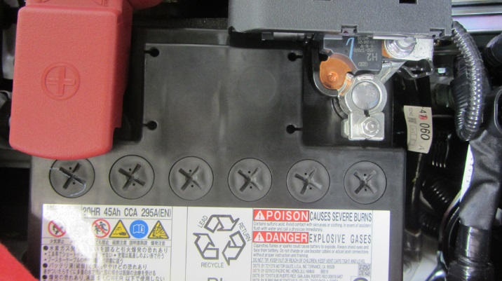
  - Remove the negative battery terminal (Fig. 1-1).
Fig. 1-1
10mm wrench
    - The battery is located in the engine compartment.
    - Do not touch the positive terminal with any part of the tool when removing the cable.

Disassemble the Vehicle.
  - If any door sill covers are present, use a standard process for removing double sided taped-on parts/badges.
NOTE: Unless otherwise specified, the procedure for the driver side and passenger side is the same.
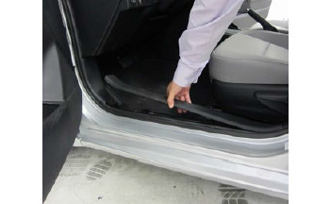
  - Disengage the two claws on the inside bottom and the four clips to remove the front left and front right inner door scuff plates (Fig. 2-1). Use a nylon pry tool if necessary.
Fig. 2-1
Panel pry tool

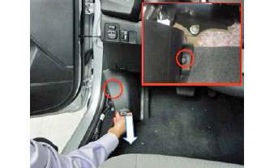
  - Remove the front left and front right cowl side covers (Fig. 2-2).
Fig. 2-2
Panel pry tool
    - Remove the retaining nut.
    - Pull the cover straight away from the body to detach one clip in the direction of the arrows. Use a nylon pry tool if necessary.
    - If a clip is stuck to the body after removal, remove the clip and reattach it to the cowl cover.
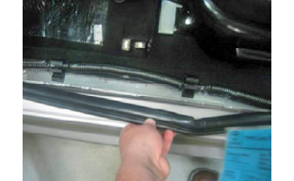
  - Detach the front left and front right weather seal from the bottom pinch weld (Fig. 2-3).
Fig. 2-3

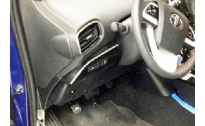
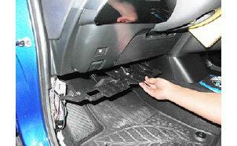
  - Remove the two screws and release the clip to remove the driver side under dash panel (Fig. 2-4 & Fig. 2-5).
Fig. 2-4
Phillips screwdriver
Screw
Screw
Clips
Fig. 2-5

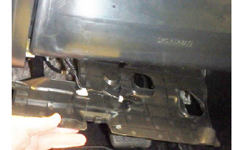
  - Disengage the foot light connector from the panel (Fig. 2-6).
Fig. 2-6

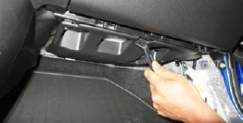
  - Release the three clips and lower the passenger side under dash panel (Fig. 2-7).
Fig. 2-7
Panel pry tool

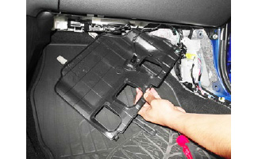
  - Disengage the foot light connector from the panel (Fig. 2-8).
Fig. 2-8

Install the Driver Side Door Sill.
  - Clean the door rocker area with VDC approved cleaner.
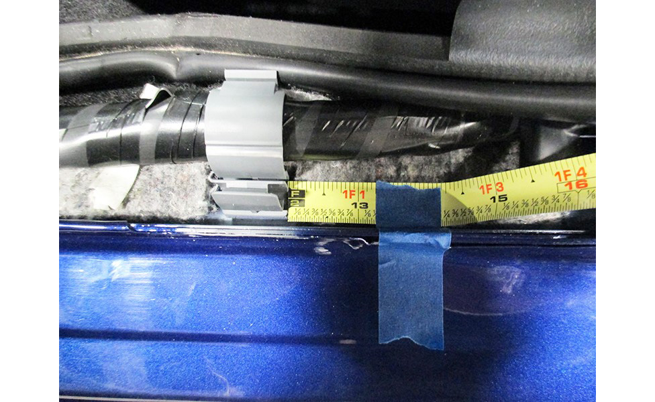
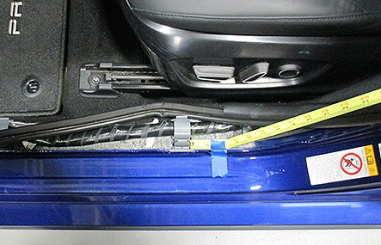
  - Locate the rear OE harness clip. Measure
1-1/4” (32 mm) from the clip towards the rear of the vehicle. Mark this location with a piece of tape (Fig. 3-1).
Fig. 3-1

Note: The work area, door sills and vehicle door surface temperature must be at least 60°F (16°C).
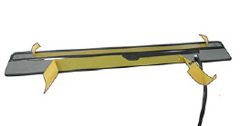
  - Remove the protective tape from the adhesive backing on the door sill (Fig. 3-2).
Fig. 3-2
Door sill crease

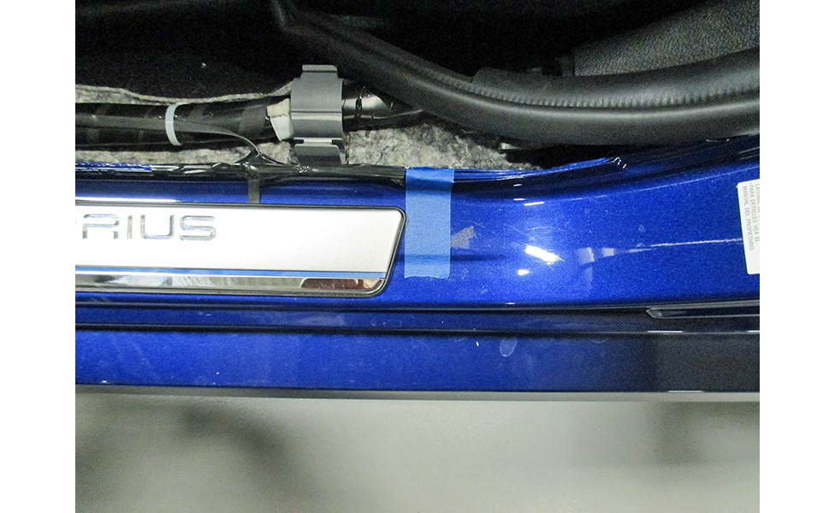
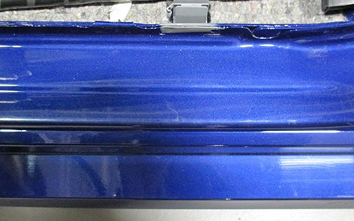
  - Align the crease under the door sill (Fig. 3-2) with the rocker crease and the rear edge of the door sill with the tape applied in Step 3(b) (Fig. 3-3). Ensure the door sill is parallel with the pinch weld and tape it down.
Fig. 3-3
Hand roller
Rocker crease
  - Press the door sill onto the rocker and use a hand roller to attach it firmly (Fig. 3-3).
  - Place one pinch weld bridge on the pinch weld in the area where the cable exits the door sill.
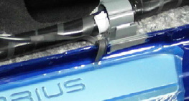
  - Cradle the door sill cable in the pinch weld bridge and cover it with electrical tape to it hold in place. Reinstall the weather seal over the pinch weld bridge (Fig. 3-4).
Fig. 3-4
Electrical tape
Pinch weld bridge
Note: Make sure the bridge ends under the soft part of the weather strip.

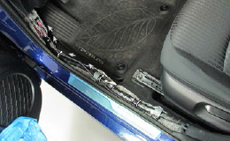
  - Thread the door sill harness inside the front OE harness clip. Secure the door sill wire to the vehicle harness with three wire ties
(Fig. 3-5).
Fig. 3-5

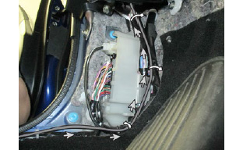
Fig. 3-6
  - Route the harness along the vehicle harness (Fig. 3-6). Do not attach wire ties yet.

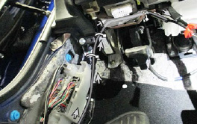
  - Continue routing the harness along the OE harness, above the hood release cable, and behind the metal bracket (Fig. 3-7). Secure it with two wire ties.
Fig. 3-7
  - Wrap one piece of foam tape around the door sill fuse.

  - Secure the harness along the vehicle harness with three wire ties (Fig. 3-8).
Fig. 3-8

Install the T-Taps.
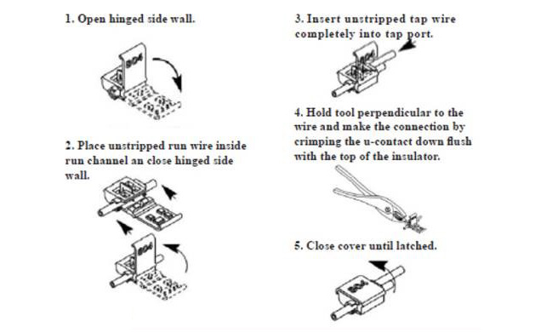
  - Review Fig. 4-1 for the proper application of T-Taps.
Fig. 4-1
  - Apply one T-Tap each to the foot light connector wires.

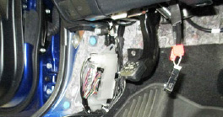
  - Connect the door sill wires to the T-Taps with the matching wire colors on the foot well lights (Fig. 4-2).
Fig. 4-2
Pliers
  - Wrap one piece of foam tape around the completed connection.
  - Clip all wire ties flush.

Install the Passenger Side Door Sill.
  - Repeat Step 3(a) through Step 3(g) on the passenger side.
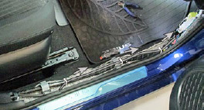
  - Thread the door sill harness inside the front OE harness clip. Secure the door sill wire to the vehicle harness with three wire ties (Fig. 5-1).
Fig. 5-1

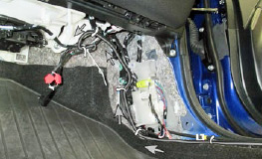
  - Wrap one piece of foam tape around the door sill fuse and apply four wire ties (Fig. 5-2).
Fig. 5-2
  - Apply one T-Tap each to the foot light connector wires.

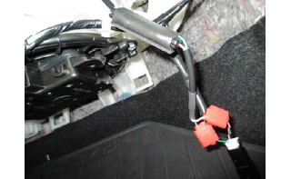
  - Connect the door sill wires to the T-Taps with the matching wire colors on the foot well lights (Fig. 5-3).
Fig. 5-3
Pliers
  - Wrap one piece of foam tape around the completed connection.
  - Clip all wire ties flush.

Install the Rear Door Sills.
  - Clean the door rocker area with VDC approved cleaner.
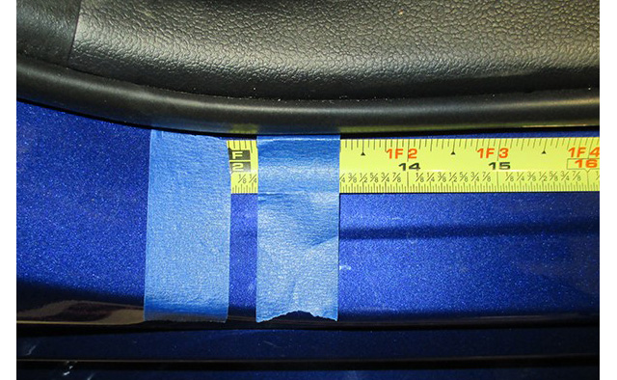
  - Starting on the driver side, mark the front edge of the rocker crease with a piece of tape. Measeure 1-1/4” (32 mm) from the edge towards the rear of the vehicle and mark with a second piece of tape (Fig. 6-1).
Fig. 6-1
Front edge of rocker crease
1-1/4”
Rocker crease

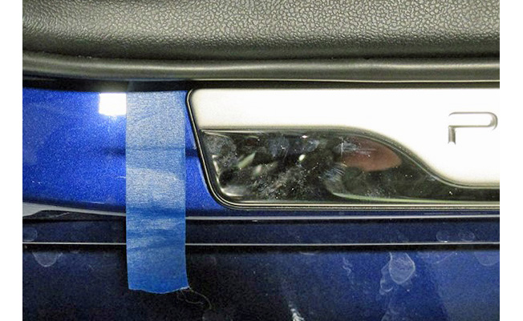
  - Install the rear door sill following Step 3(c) to Step 3(e), aligning the front of the door sill with the tape applied in Step 3(b) (Fig. 6-2).
Fig. 6-2
  - Repeat for the passenger side.

Test the Door Sills.
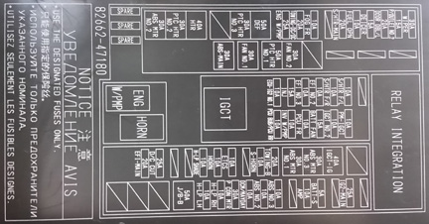
  - Temporarily reconnect the negative battery terminal. If required, install the short pin (Fig. 7-1).
Fig. 7-1

  - Press in the front door courtesy switches to check the function of the front door scuff plates.
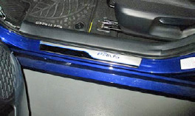
    - The door sill light should be on with the door(s) open (Fig. 7-2).
Fig. 7-2
    - The door sill light should turn off after 15 seconds when all of the door courtesy switches are pressed in.

Reassemble the Vehicle.
  - Reassemble the vehicle by reversing Step 2(a) through Step 2(h).
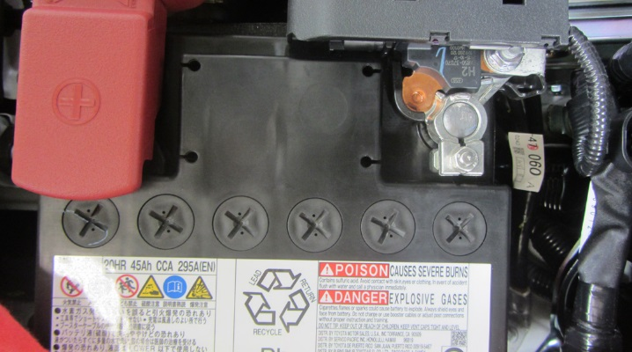
  - Tighten the negative battery cable (Fig. 8-1).
Fig. 8-1
10mm socket & torque wrench
    - Position the negative battery cable at the original factory position.
    - Tighten the nut to 5.4 N-m (48 lbf-in) of torque.
Torque: 5.4 N-m (48 lbf-in)
    - Do not touch the positive battery terminal with any tool when replacing the cable.

Accessory Function Checks
Door sill fit
Open the front doors
Press the courtesy switch

Vehicle Function Checks
Door courtesy lights
Radio
Power mirrors
Dimmer
Instrument cluster
Hazard switch
Passenger airbag indicator
Foot lights

No uneven gaps around the edges; clips securely fastened
Front door sill lights turn on
Front door sill lights turn off for each side

Front door courtesy lights operate normally
Radio functions normally
Mirrors function normally
Dimmer functions normally
Instrument cluster functions normally
Hazard switch function normally
Passenger airbag indicator light turns on
Foot lights come on with door open & turn off after 15 seconds when door is closed

Vehicle Appearance Check
After accessory installation and removal of protective cover(s), perform a visual inspection.

Ensure no damage (including scuffs and scratches) was caused during the installation process.
(For PPO installations, refer to TMS Accessory Quality Shipping Standard.)

